American restaurant

Introduction

The City of Jeddah of the most populous city in the Saudi Arabia, there a lot of Cultures in Jeddah because the Muslims come there before he wants to do umrah, there is a port for receive the luggage and merchandise.

Business Problem

The client wants to start a business again and open American restaurant in Jeddah city, but the problem was in the first time he opened the restaurant, the restaurant has been failed and he didn’t know why! especially he has a branch in another city and the restaurant work doing well.

First of all, the client wants start American restaurant in Jeddah so get all information from Foursquare about restaurant because We believe that the location One of the reasons to success the restaurant.

Second thing that we got json file and it has a lot of text so we convert it to data frame and clean it and do drop all column we don’t need also we make csv file to make update for some miss info.

After that we want where the most street have American restaurant so we do this chart:

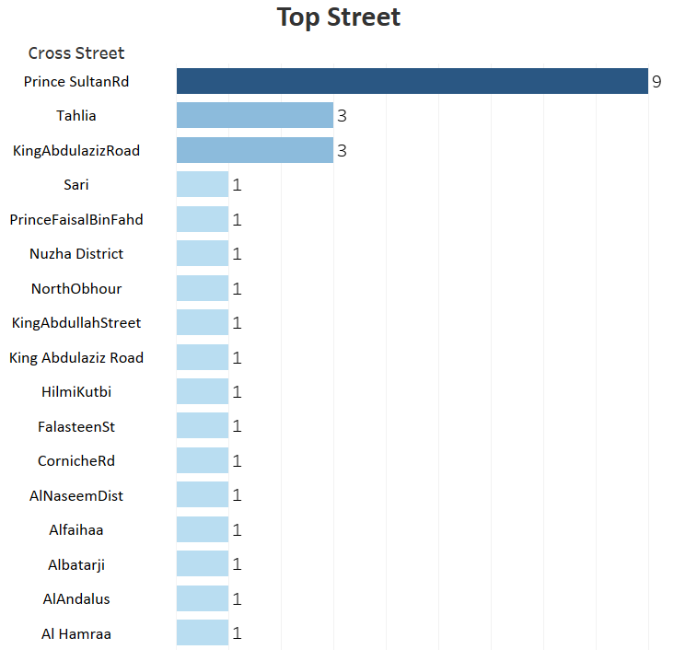

As we can see the prince sultanRD has the most American restaurant then Tahlia and so on.

Finally, we need to use a model they can see where the locations of the restaurants for that we make cluster by using K-means and elbow method to see the best number of clusters.

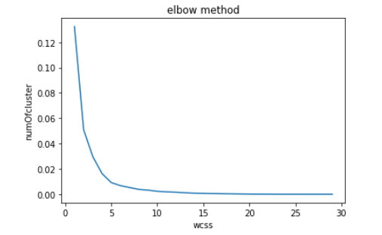

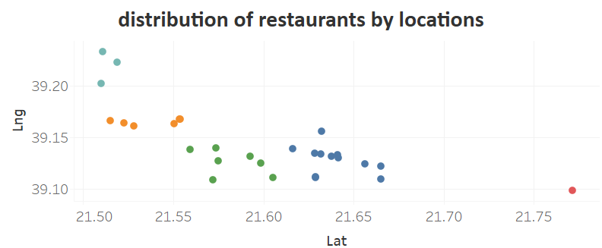

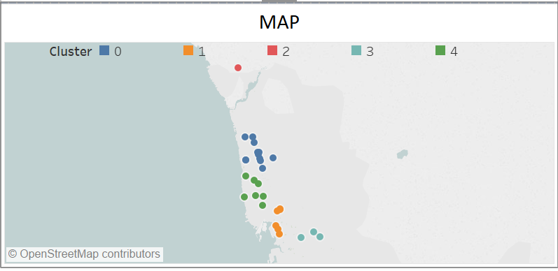

As we can see the most point with a blue colour that can client open in that area and we also make a map for the restaurants.

Conclusion:

We believe that the location One of the reasons to success the restaurant so we will find a good place to open the restaurant by using Foursquare Developer.

The Foursquare provide us a lot of information about the restaurant like location, classification and menu. so we will use a python to collect the data, cleaning and modelling.